Miss Bawn  Grade 3 | October 2016
Sunday | Monday |  | Tuesday | Wednesday | Thursday | Friday | Saturday
 |  |  |  |  |  |  | 1
2 | 3 |  | 4 | 5 | 6 | 7 | 8
 |  |  | Picture Day  MUSIC | GYM | Professional Dev.  MUSIC | Professional Dev.  LIBRARY/GYM
9 | Thanksgiving 10 |  | 11 | 12 | 13 | 14 | 15
 | 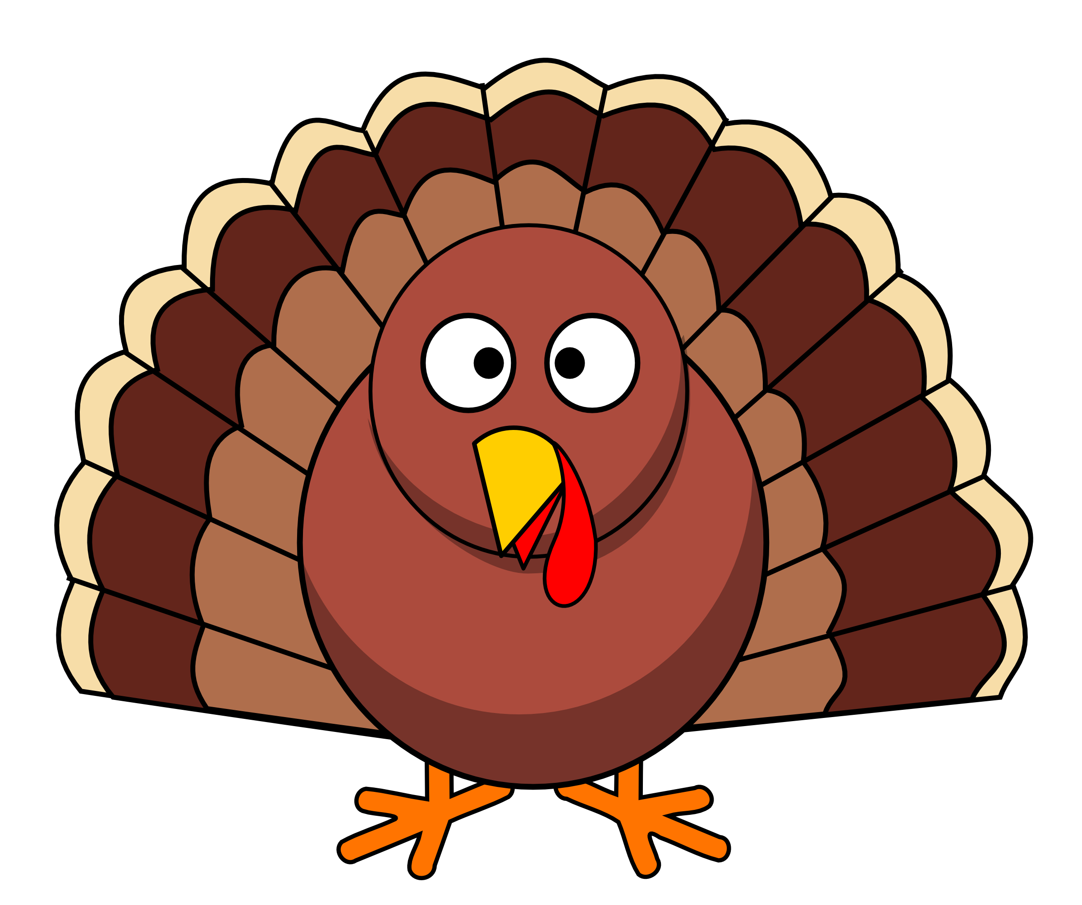  GYM |  | MUSIC | GYM | MUSIC | LIBRARY/GYM
16 | 17 |  | MUSIC 18 | 19 | 20 | 21 | 22
 | GYM |  | 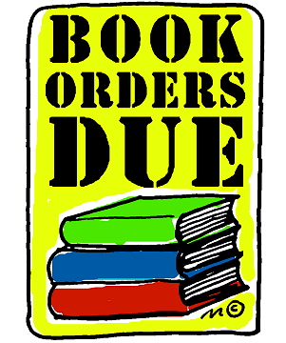 | Hot Lunch orders and $ due  GYM | MUSIC | LIBRARY/GYM
23 | 24 |  | 25 | 26 | 27 | 28 | Truck N Treat 29
 | GYM |  | MUSIC | GYM | MUSIC | LIBRARY/GYM | SCES 1-3pm
30 |  | 31

