Miss Bawn  Grade 3 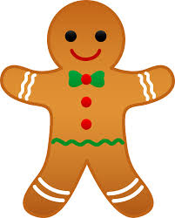 | December 2016
Sunday | Monday | Tuesday | Wednesday | Thursday | Friday | Saturday
 |  |  |  | 1 | 2 | 3
 |  |  |  | MUSIC | GYM/LIBRARY | SCES Craft & Trade Show 9am-3pm
4 | 5 | 6 | 7 | 8 | 9 | 10
 | GYM | MUSIC | 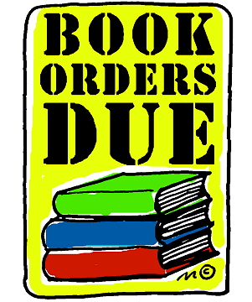  GYM | MUSIC | GYM/LIBRARY
11 | 12 | 13 | 14 | MUSIC 15 | 16 | 17
 | GYM | MUSIC | Hot Lunch Orders and $ Due  GYM | Annual Christmas Dinner @ the church hall  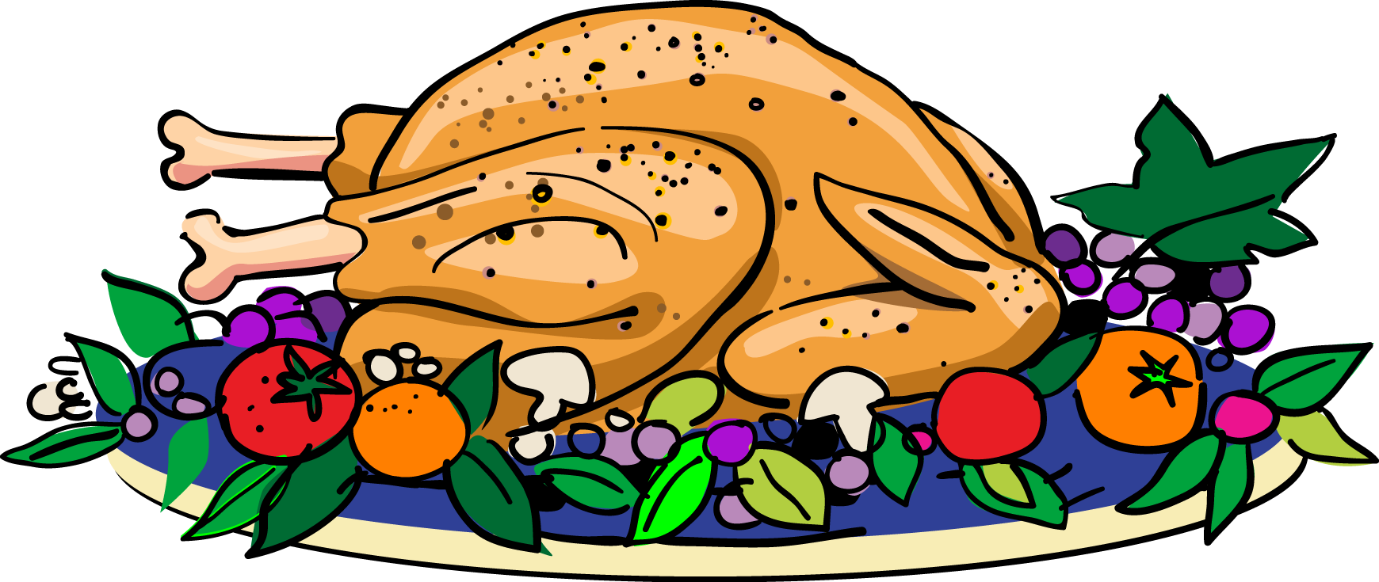 | GYM/LIBRARY
18 | 19 | 20 | 21 | MUSIC 22 | 23 | 24
 | GYM | MUSIC | Christmas Concert  9:30am & 12:30pm | Storm Date for Christmas Concert | ½ day for students | Christmas Eve / Hanukkah  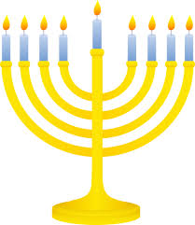
25 | 26 | 27 | 28 | 29 | 30 | 31
Christmas Day Kwanzaa

